Software Architecture and Design Specification: Ischemia Predictor
- ☐ Version 1.1 (updated after implementation) · Ischemia Detection Team · Oct 31, 2026 · @Bindushree

1 Introduction

1.1 Purpose
This document describes the architecture and detailed design of Ischemia Predictor as built: how the system is split into components, how they interact, and how each requirement in the SRS (v1.1) is realized. Version 1.1 records the implemented design and its differences from version 1.0 (Section 5). It is the basis for the Test Plan (TP-IP-001 v1.1).

1.2 Scope
The design covers the web client, the Python Flask web server, the ML, DL and QML prediction microservices, the database, the offline training pipeline, and the deployment setup (Docker containers started with Docker Compose). Kubernetes orchestration is the intended production design but is not part of this release (Section 5, D8).

1.3 References
- Software Requirements Specification, Ischemia Predictor v1.1 (FR-xx, NFR-xx, SEC-xx)
- Test Plan TP-IP-001 v1.1
- IEEE Std 1016-2009, Software Design Descriptions
- OWASP ASVS 4.0

1.4 Definitions
Term | Meaning
Web client | Browser-based user interface (HTML, CSS, JavaScript)
Web server | Python Flask application exposing the REST API (acts as API gateway)
Microservice | Independently deployable prediction service (ML, QML or DL)
Container | Packaged runtime of one service (Docker)
Pipeline | The versioned preprocessing artifact (pipeline-1.0) shared by training and inference
Model registry | Database table plus registry.json listing model versions, checksums and validation status

2 Architecture

2.1 Architectural Overview
A clinician uses the web client in a browser. The client reaches the web server over HTTP(S). The web server (Python Flask) authenticates the user, validates and preprocesses the data, and calls one of three prediction microservices (ML, DL, QML). Results and history are saved in the database. The dataset (heart.csv) is used offline to train and validate the models that the microservices serve.

2.2 Architectural Pattern
The system combines three patterns:
- Client–server: a thin browser client and a central server that holds all business rules.
- Microservices: each model type runs as its own service with a fixed REST contract, so models can be developed, updated and scaled independently (FR-23, NFR-10).
- API gateway with layered internals: the Flask server is the single entry point, so the client never talks to a microservice directly (SEC-08).
Why this pattern: the model families use different libraries and runtimes (scikit-learn, quantum simulator). Separating them avoids dependency conflicts, isolates failures (one service down does not stop the others) and allows scaling the slowest service (QML) separately.

2.3 Component Diagram
Figure 1: component diagram, showing the components and the connections between them.
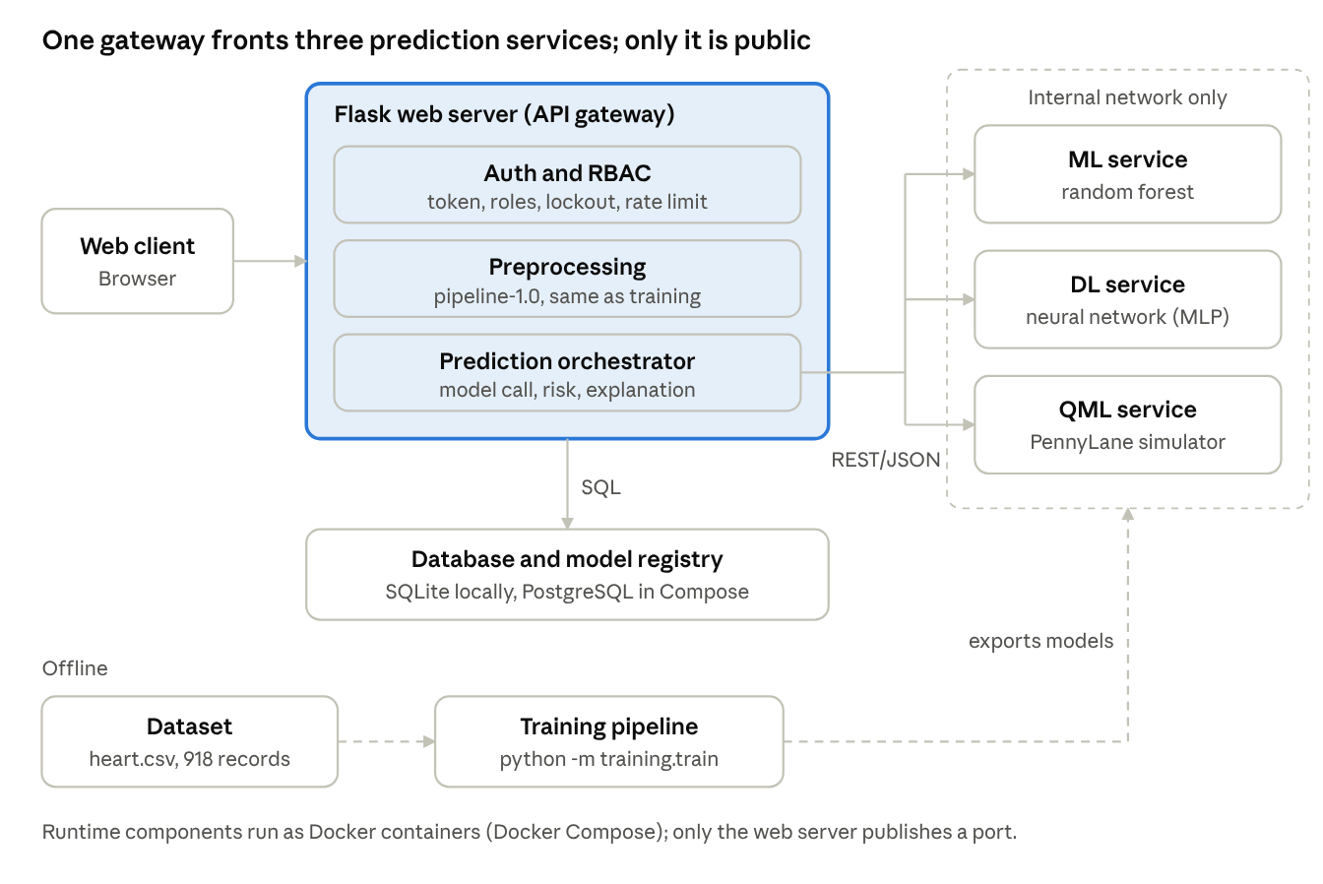
component diagram · 7 runtime components, 1 offline path
The browser reaches only the Flask gateway; the three model services and the database sit behind it, and the dataset feeds offline training only.

2.4 Component Description
Component | Responsibility | Technology | Key requirements
Web Client | Login, data entry form, result, history and admin pages; field-level errors and the medical disclaimer | HTML, CSS, JavaScript | FR-04, FR-06, FR-14, FR-16, UI-1 to UI-4
Web Server (API gateway) | REST API, session tokens, input validation, orchestration, error handling, rate limiting | Python, Flask, Flask-SQLAlchemy | FR-01 to FR-03, FR-05, FR-17, SEC-09
Auth and RBAC module | Password check, signed session token, role check on every endpoint, lockout | PyJWT, bcrypt | FR-01, FR-02, SEC-01, SEC-02, SEC-04
Preprocessing module | Imputation, scaling and encoding identical to training; pipeline version check | scikit-learn pipeline (shared common/ library) | FR-07, FR-08
Prediction Orchestrator | Selects the model service, calls it (one retry), applies risk thresholds, builds the explanation | Flask service layer | FR-09, FR-12, FR-13, FR-15
ML Service | Random-forest prediction and leave-one-out feature attribution | Python, scikit-learn | FR-09, NFR-06
DL Service | Neural-network (MLP) prediction | Python, scikit-learn MLPClassifier | FR-09, NFR-06
QML Service | Quantum-circuit prediction on a simulator, Platt-calibrated probability | Python, PennyLane | FR-09
Model Registry | Model versions, validation status, SHA-256 checksums, active version | Database table plus registry.json and model files | FR-22 to FR-24, SEC-07
Database | Users, predictions (inputs encrypted), model records, audit logs | SQLite (local), PostgreSQL (Compose) | FR-19, FR-20, SEC-05
Training Pipeline (offline) | Splits data, fits the pipeline, trains and cross-validates models, writes registry and report | Python scripts (python -m training.train) | NFR-06, FR-07

2.5 Deployment View
Each runtime component (web server, three prediction services, database) runs in its own Docker container. docker-compose.yml starts them together; only the web server publishes a port, and the prediction services and database are reachable only on the internal Compose network (SEC-08). Containers make the system portable to any Linux host (NFR-13).
Kubernetes (restarting failed containers, scaling replicas for NFR-03 and NFR-08, HTTPS ingress) is the intended production design, but no Kubernetes manifests are delivered in this release (Section 5, D8).

2.6 Traceability to Requirements
SRS requirement | Realized by (component) | Design element
FR-01 to FR-03 | Auth and RBAC module | POST /auth/login; signed token with 15-minute expiry, renewed on each request
FR-04 to FR-06 | Web Client, Web Server | Form UI, validation ranges, VALIDATION_ERROR response listing every invalid field
FR-07, FR-08 | Preprocessing module | Versioned pipeline (pipeline-1.0), version check before each call
FR-09 to FR-15 | Prediction Orchestrator, ML/DL/QML services | POST /predictions, internal POST /predict, risk thresholds in configuration
FR-16 | Web Client | Clear button resets form state
FR-17, FR-18 | Web Server | 10-second limit with one retry, SERVICE_UNAVAILABLE error, structured error log
FR-19 to FR-21 | Database, Web Server | predictions table, GET/DELETE /predictions
FR-22 to FR-24 | Model Registry | models table, registry.json, PUT /models/{id}/activate
NFR-01, NFR-03, NFR-08 | Containers, microservices | Stateless services and replicas (design; not yet measured)
NFR-06, NFR-07 | Training Pipeline, services | Held-out validation gate, fixed random seeds, deterministic inference
NFR-10, NFR-13 | Whole system | Separate modules and containers; pytest suite
SEC-01 to SEC-10 | Section 2.7 | Security architecture below

2.7 Security Architecture
Layer | Control | Requirement
Network | TLS 1.2+ required at the ingress or reverse proxy (the development server uses HTTP); prediction services and database reachable only on the internal Compose network | SEC-03, SEC-08
Authentication | Salted bcrypt hashes, policy of 10+ characters enforced by the admin API, lockout after 5 failures for 15 minutes, signed token in the Authorization header | SEC-01, SEC-02
Authorization | Role check as a decorator on every protected endpoint; HTTP 403 on violation | SEC-04
Input protection | Range and type validation on all inputs; ORM (parameterized SQL) only; client renders text with textContent; prediction services accept only schema-valid, finite JSON up to 16 KB | SEC-06
Data protection | AES-256-GCM encryption of stored inputs; auto-generated pseudonymous patient_ref; no patient data in logs | SEC-03, SEC-10 (partial)
Model integrity | SHA-256 checksum verified when a model is registered and again when a service loads it; only models marked validated are served | SEC-07, FR-22
Abuse protection | 60 requests per minute per user, held in memory per process | SEC-09
Accountability | Audit log for login, prediction, deletion, model activation and user creation; records are never purged | SEC-05

2.8 Other Design Decisions
- The web server keeps no session state (signed tokens); the only in-memory state is the rate-limit counter.
- Prediction services are stateless and read-only: they load a model version on first use, verify its checksum, cache it and only compute.
- Risk thresholds (30% and 70%) and the default model are configuration values (RISK_LOW, RISK_HIGH, DEFAULT_MODEL), not administrator screens.
- A prediction is stored only after validation and a model reply.
- The QML service runs on a simulator in this release (SRS assumption).

3 Design

3.1 Sequence Flows
Two scenarios are modelled: login with lockout handling, and the main prediction flow.
SD-1: User login (FR-01, FR-03, SEC-02)
- The client sends username and password to POST /auth/login.
- The server looks the user up. If the account is locked, it returns ACCOUNT_LOCKED (423).
- The server checks the password against the bcrypt hash.
- On success it resets the failure counter, writes a login audit entry and returns a signed token (15 minutes) and the role.
- On failure it increments the counter and returns UNAUTHENTICATED (401). The fifth consecutive failure locks the account for 15 minutes and returns ACCOUNT_LOCKED (423).
- Every later authenticated response carries a renewed token in the X-Token header, so the session ends after 15 minutes of inactivity.
SD-2: Get prediction (FR-05 to FR-13, FR-17, FR-19)
- The client sends the 11 fields and the chosen model to POST /predictions with the token.
- The server checks the token, the role and the rate limit (UNAUTHENTICATED, FORBIDDEN, RATE_LIMITED).
- The server validates every field. If any is invalid it returns VALIDATION_ERROR (400) listing all invalid fields, and calls no service.
- The server finds the active, validated model of the chosen type. If there is none it returns SERVICE_UNAVAILABLE (503).
- The server checks that the model's pipeline version equals the current pipeline version (otherwise PIPELINE_MISMATCH) and applies the pipeline to the inputs.
- The server calls the model service POST /predict within a 10-second limit and retries once. If both attempts fail it returns SERVICE_UNAVAILABLE (503) and the client keeps the entered data.
- The service verifies the model checksum, computes the probability and the top-5 leave-one-out contributions, and replies.
- The server assigns the risk category, stores the prediction (inputs encrypted), writes a prediction audit entry and returns 201 with label, probability, risk, top features, model version and disclaimer.

3.2 Data Design
Table | Main columns
users | id, username, password_hash, role, failed_attempts, locked_until
predictions | id, user_id, patient_ref (pseudonymous), inputs (AES-256-GCM encrypted JSON), label, probability, risk, model_version, created_at
models | id, type (ML, DL, QML), version, status (validated or unvalidated), checksum, file, pipeline_version, is_active
audit_logs | id, user_id, action, ip, timestamp

3.3 API Design
All endpoints are under /api/v1, use JSON and require a bearer token except login.
Public API (web client → web server)
Method and path | Purpose | Role | Success | Errors
POST /auth/login | Log in, returns token and role | All | 200 | 400, 401, 423
POST /auth/logout | End session | All | 204 | 401
POST /predictions | Validate data and get a prediction | Clinician, ML Engineer | 201 | 400, 401, 403, 429, 503
GET /predictions?page= | List own history, 20 per page, newest first | Clinician, Administrator | 200 | 401, 403
GET /predictions/{id} | One stored prediction (own) | Clinician | 200 | 401, 403, 404
DELETE /predictions/{id} | Delete a record | Administrator | 204 | 401, 403, 404
GET /models | List model versions | Administrator, ML Engineer | 200 | 401, 403
POST /models | Register a new model version (checksum verified) | ML Engineer | 201 | 400, 401, 403
PUT /models/{id}/activate | Activate a validated version | Administrator | 200 | 401, 403, 404, 409
POST /admin/users | Create a user (password policy enforced) | Administrator | 201 | 400, 401, 403
GET /admin/audit-logs | View the latest 200 audit entries | Administrator | 200 | 401, 403
Request example: POST /predictions
{
"model": "ML",
"age": 58,
"sex": 1,
"chest_pain_type": 3,
"resting_bp": 140,
"cholesterol": 240,
"fasting_bs": 0,
"resting_ecg": 1,
"max_hr": 120,
"exercise_angina": 1,
"oldpeak": 1.5,
"st_slope": 1
}
Codes for each field are listed in SRS FR-04. An optional patient_ref may be supplied; if omitted a pseudonymous one is generated.
Response example (201)
{
"prediction_id": "p-1a2b3c4d",
"label": "Ischemia Likely",
"probability": 72.4,
"risk": "High",
"top_features": [
{"name": "st_slope", "direction": "increases"},
{"name": "exercise_angina", "direction": "increases"}
],
"model_version": "ml-1.0",
"disclaimer": "Decision-support output; not a substitute for professional medical diagnosis."
}
Internal API (web server → microservice, internal network only)
Method and path | Purpose | Response
POST /predict | Input: scaled feature vector (11 values), pipeline_version, model_version. Rejects wrong length or type, NaN/Infinity, bodies over 16 KB | label, probability, importances, model_version, model_type, latency_ms; errors 400, 409 (pipeline mismatch), 413, 503 (model not validated or checksum failure)
GET /health | Liveness check | 200 with the service type
GET /info | Served model versions with recorded metrics and the feature list | 200; 503 if the registry is unreadable

3.4 Error Handling
Every error returns a JSON body {"error_code", "message", "request_id", "fields"?}. Messages are written for clinicians and never expose stack traces, SQL or patient data. Each error is logged with timestamp, error code and request ID only (FR-18). A catch-all handler turns any unexpected failure into INTERNAL_ERROR and logs only the exception type.
The web server retries a failed microservice call once, within the same 10-second limit, before returning 503. The entered data stays in the form; the user selects another model manually if needed (Section 5, D15).
Error code | HTTP | Condition | Behaviour
VALIDATION_ERROR | 400 | Field missing, wrong type or out of range | Lists every invalid field with its valid range; no prediction call (FR-05, FR-06)
UNAUTHENTICATED | 401 | Missing, invalid or expired token; wrong password | Client returns to login
FORBIDDEN | 403 | Role not allowed | No data returned (SEC-04)
NOT_FOUND | 404 | Record does not exist or is not the user's own | Generic not-found message
ACCOUNT_LOCKED | 423 | 5 failed logins in a row | Locked for 15 minutes (SEC-02)
MODEL_NOT_ACTIVATABLE | 409 | Model not validated | Activation refused (FR-22)
RATE_LIMITED | 429 | More than 60 requests per minute | Retry-After: 60 header
SERVICE_UNAVAILABLE | 503 | No active validated model, or service down or silent for 10 seconds | "Prediction service temporarily unavailable, please retry"; entered data kept (FR-17)
PIPELINE_MISMATCH | 500 | Pipeline version differs from the model's | Request rejected and logged (FR-08)
INTERNAL_ERROR | 500 | Any unexpected failure | Generic message with request ID

3.5 User Interface Design
Four screens in one page application: Login, Prediction (entry form and result), History, and Admin (users, models, audit logs). Numeric inputs show their unit and valid range in the label; categorical inputs are dropdowns. Invalid fields are outlined in red with a message beside the field. The result always shows the label, probability, risk category, model version, top features and the disclaimer. The layout is responsive (UI-1 to UI-4; behaviour at 360 px not yet verified).

3.6 Assumptions
- The dataset is used only offline for training and validation; the running system does not read it.
- Quantum ML is executed on a simulator.
- The final feature list is SRS FR-04; final model metrics are in SRS Appendix D.

4 Training and Validation Design
The offline pipeline (python -m training.train --data data/heart.csv --models models) works as follows:
- Load heart.csv, encode categorical columns as integers, treat cholesterol and resting blood pressure values of 0 as missing.
- Split 80/20, stratified by label, seed 42. The 20% test split is saved as heldout.csv.
- Fit the preprocessing pipeline (median imputation, standard scaling) on the training split only, and save it as pipeline-1.0.joblib.
- Train the ML model (random forest, 400 trees). Train the DL model (MLP) with its settings chosen by 5-fold cross-validation on the training split. Train the QML model (4 qubits chosen by random-forest importance, 3 layers, mini-batch training, Platt-calibrated output).
- Evaluate each model on the held-out split (accuracy, recall, precision, F1, ROC-AUC, confusion matrix). Report 5-fold cross-validation for ML and DL, with preprocessing refitted inside each fold.
- Mark a model validated only if held-out accuracy and recall are both at least 85% (NFR-06). Write each model's SHA-256 checksum to registry.json, and write training_report.json with the dataset hash, date, seed and metrics.
Results of the current run are in SRS Appendix D.1: ML 90.2% accuracy and 93.1% recall, DL 87.0% and 91.2%, QML 78.8% and 83.3% (unvalidated, not served).

5 Deviations from Design Version 1.0
# | Area | Version 1.0 design | As built
D1 | Dataset | UCI heart disease, final choice pending | heart.csv, 918 records, 11 inputs; label is a proxy for ischemia
D4 | DL service | TensorFlow/PyTorch | scikit-learn MLP
D5 | QML service | Quantum SDK | PennyLane simulator; below the 85% target, so unvalidated and not served
D6 | Explanation | Top-5 features | Leave-one-out attribution; internal feature names
D7 | TLS | TLS 1.2+ at the ingress | Development server uses HTTP; TLS left to the ingress or reverse proxy
D8 | Orchestration | Kubernetes | Docker Compose only; Kubernetes manifests not delivered
D9 | Database | PostgreSQL with migration scripts | SQLite locally, PostgreSQL in Compose; tables created by the app
D10 | Configuration | Administrator changes thresholds and default model | Server settings
D11 | Rate limit | 60 per minute per user | In-memory, per process
D12 | Pseudonymisation | Replace patient identifier | Auto-generated patient_ref; no replace function
D13 | Audit retention | 1 year | Records never purged; no retention job
D14 | Admin functions | Admin UI | Delete prediction and register model are API-only
D15 | Failure handling | Offer another model | User selects another model manually
D16 | UI | Five pages | Four screens; result shown on the Prediction screen
D18 | Retraining | Not specified | Version names reused; reset the database or rename versions after retraining
D20 | Internal API | /predict, /health | Adds /info, latency_ms, NaN/Infinity rejection, 16 KB limit
The full numbered list (D1 to D20) is in SRS Appendix D.3.

